*Question # 1:*

*You have been given a graph with Edge values and Node values:*

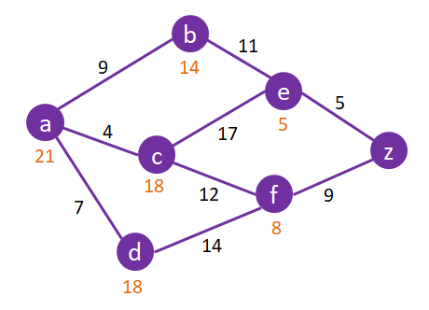

*Show Expansion for the following algorithms and their paths found for Node A -> Node Z:*

* **A\***

*Path:*

*Expansion:*

* **BFS**

*Path:*

*Expansion:*

* **DFS**

*Path:*

*Expansion:*

* **UFC**

*Path:*

*Expansion:*

*Question # 2:*

*You have been given a tree with Node Variable Values:*

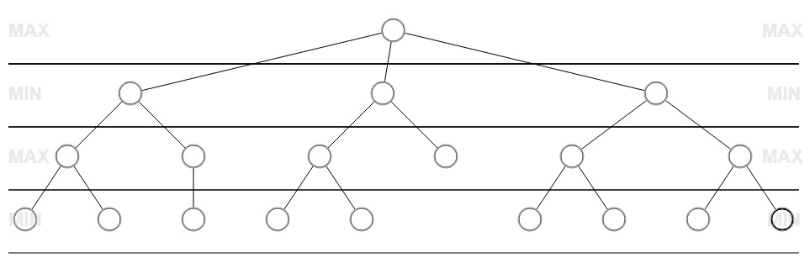

*Leaf Node Variable Values from Left to Right:*

*1. x = 2, y = 3, z = 10 6. x = -3, y = -2, z = 4*

*2. x = 3, y = 4, z = 5 7. x = 6, y = 8, z = 2*

*3. x = 5, y = 2, z = 6 8. x = 7, y = -4, z = 3*

*4. x = 4, y = -3, z = 7 9. x = -4, y = 6, z = 8*

*5. x = -2, y = 5, z = 9 10. x = 8, y = -5, z = 11*

*Use the evaluation formula x^(y/log(z)) to calculate the node values, then apply alpha – beta pruning.*